Geo-Seas
Pan-European infrastructure for management of marine and ocean geological and geophysical data


Deliverable 4.5: Geophysical data transport format

Organisation name for lead contractor for this deliverable: OGS

Date due: december 2009
Date submitted: february 2010
Project acronym: Geo-Seas
Project full title: Pan-European infrastructure for management of marine and ocean geological and geophysical data
Grant Agreement Number: 238952
Start date of project: 1st May 2009

Co-ordinator:



Deliverable number | Short Title
4.5 | Geophysical data transport format
Long Title
Deliverable 4.5 – Geophysical data transport format
Short Description
Report on standards to be used within Geo-Seas while transferring/sharing Geophysical data
Keywords
Geo-Seas geophysical transport standards
Authors / Organisation(s) | Editor / Organisation
Paolo Diviacco (OGS) | Dick Schaap (MARIS) /Colin Graham (BGS)
File name
D4-5_GS_WP4_Geophysical_Formats_Draft_V2.doc
Deliverable due date | Deliverable submitted date
December 2009 | March 2010
Comments

History
Version | Author(s) | Status | Date | Comments
001 | Paolo Diviacco (OGS) | Draft | 25 february 2009
002 | Dick Schaap (MARIS) | Final | March 2010

Dissemination level
PU | Public
CO | Confidential, for project partners and the European Commission only | X

Content

1 Executive Summary 4
2 Work Package 4.5 Transport formats for Geophysical data
2.1 Introduction 4
2.2 Applied approach
3 Description of SeaDATANET standards (ODV, netcdf)
3.1 Introduction 6
3.2 ODV
3.3 netCDF
4 Data transport for Geophysical data
4.1 Introduction 8
4.2 Transport format specifications for Seismic data
4.2.1 The SEG-Y format
4.2.1.1 Textual file header
4.2.1.2 Binary reel header
4.3 Transport format specifications for Seismic data positioning
4.3.1 P1/90 format descriptiont
4.3.1.1 Header record
4.3.1.2 Mandatory headers
4.3.1.3 Recommended headers
4.3.1.4 Data Record
4.3.1.5 3D case
4.4 Transport format specifications for side-scan sonar
5 REFERENCES
Appendix 1: Full technical specification for SEG-Y file format
Appendix 2: Full technical specification for file format P1/90
Appendix 3: Example of P1/90 Header record
Appendix 4: Example of P1/90 Data record

- Executive Summary
Geo-Seas is a sibling of the SeaDataNet initiative and will adopt its approach, architecture and middleware.
On the other hand SeaDataNet was developed for the Oceanographic community, which means that the extension of the framework towards Geophysics and Geology needs some tailoring to fit the practices and traditions of a different research field.
In this perspective Work package 4 was intended to develop content standards, profiles and common transport and service protocols and within WP4 task WP4.5 was intended to define transport format standards for Geophysics
The objectives of the WP4.5 were:
- To collaboratively review the standards for Geophysical data sharing
- To collaboratively analyze practices and protocols used in Geophysical data sharing
- To define the formats to be adopted
It was clear soon that, while for most of the Geophysical data types, as for example Gravimetric data or Magnetic data, most of the technologies already adopted within SeaDataNet could be straightforwardly re-used, Seismic data need a specific consideration, and therefore specific formats.
- Work Package 4.5: Transport formats for Geophysics data
  - Introduction
The aim of the Geo-Seas EU project is to create a common data space for all the interconnected data centres of its partners where end users will be able to find Geological and Geophysical data to support their studies.
The Geo-Seas project is a sibling of the SeaDataNet EU project, and aims at adopting, where possible, the philosophy and technical solutions there developed. These letter were the outcomes of a careful analysis of the SeaDataNet target research field, which was Oceanography.
Porting the experience of SeaDataNet toward Geology and Geophysics requires studying the practices and traditions of different research fields. In fact each research community tend to evolve separately and to live within specific paradigms that result in different and concurrent vocabularies, for example the concept of a layer is different for a geophysicist and a geologist. Besides, the sampling strategies can differ from field to field and this has to be taken into account since this is reflected in defining what actually has to be shared.
  - Applied approach
Data types tend to trigger communities that in using them isolate themselves from the other thematic fields. In addition to this it is important to consider also the impact of commercial software that for marketing reasons tends to develop brand-oriented standards, in fact defining a proprietary format or at least a standard format dialect, software houses prevent users from including in their portfolios software from their competitors. This drives to a situation where standards are always to be interpreted; a situation absolutely to be avoided within the Geo-Seas projects where instead end users should expects to find homogeneous, standardized and hassle-free formats. It was decided to consider carefully and collaboratively each data type, and its usage among partners in order to converge to shared specifications that could meet the expectations of all the partners.
To ease the creation of such a shared perspective, Work package partners met twice (meeting in Utrecht and Bruxelles) to agree on the overall view and used a web based Computer Supported Collaborative Work (CSCW) toolkit called COLLA to reach consensus on all the details.
This service, hosted by OGS, aimed at consolidating in one platform all information, files, documents and messaging shared by the partners of the Work package. The portal allows applying a graphical task map to identify thematic areas or issues to discuss, and to organize within each of them the information available and the relative discussion.
All the partners receive automatic notifications of the status of the system via e-mail. All documents are available to all the partners with file naming and versioning control. Snapshots from Colla can be seen in the figures below
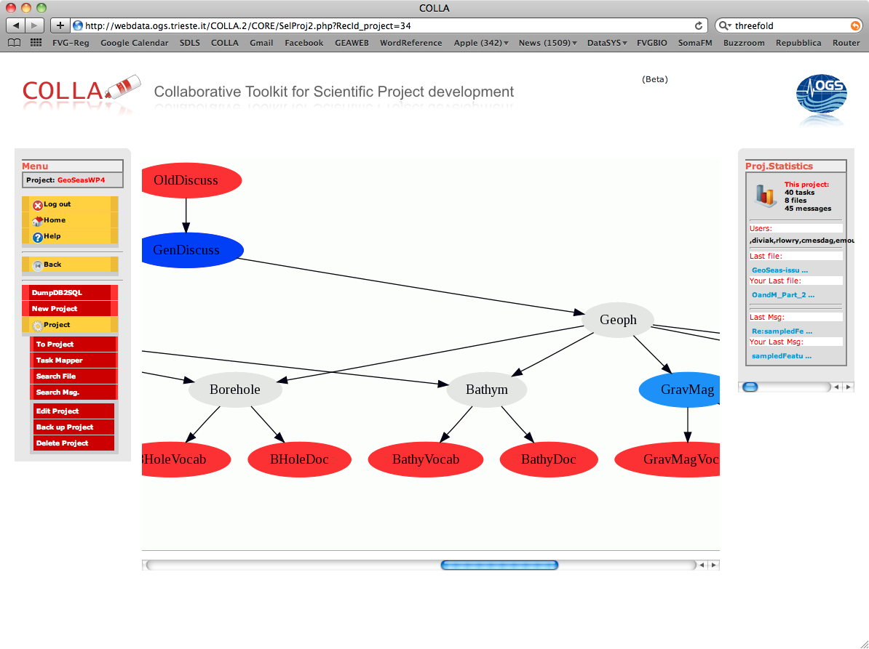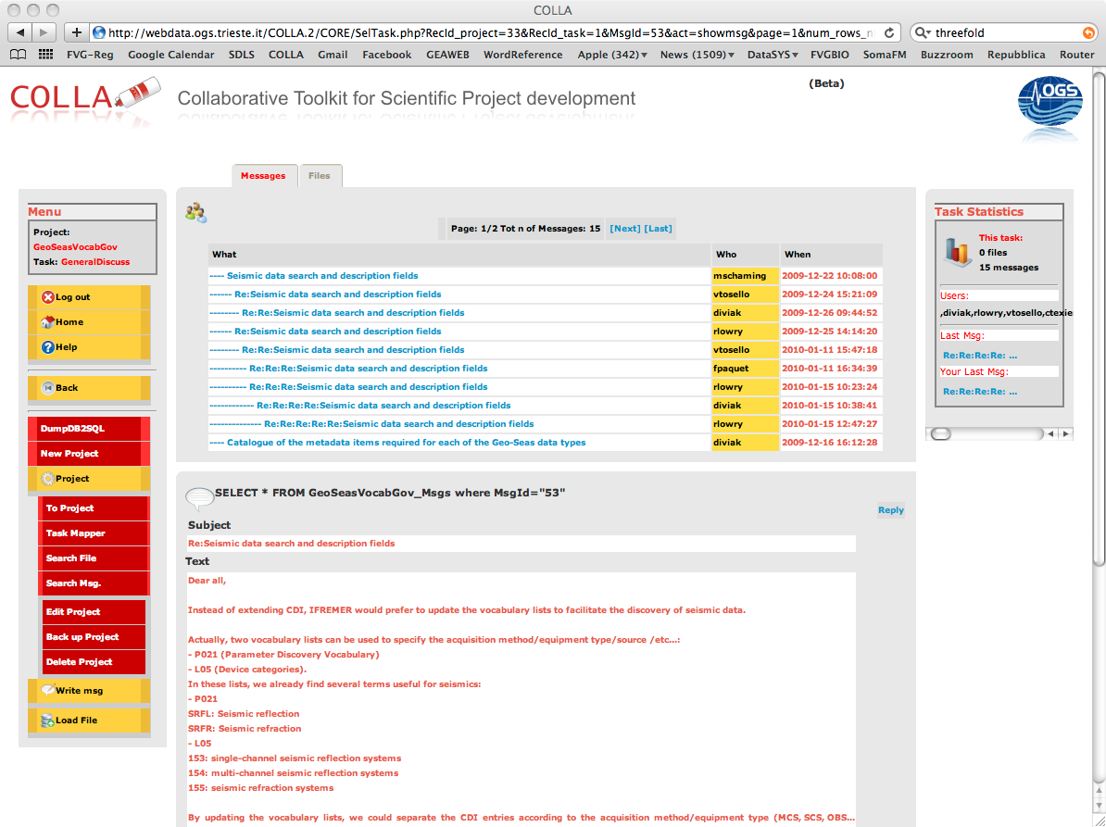

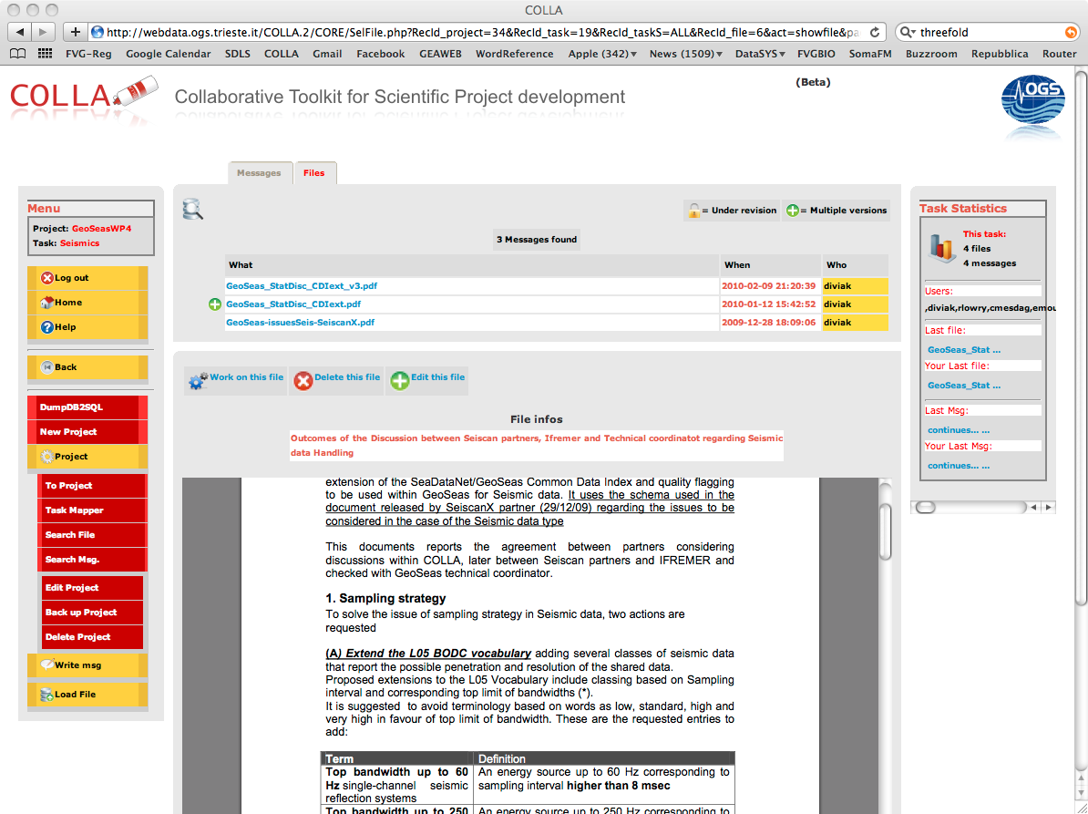

- Description of SeaDataNet standards (ODV, NetCDF)

Introduction
The SeaDataNet infrastructure comprises a network of 40 interconnected data centres and a central SeaDataNet portal. This provides users a unified and transparent overview of the metadata and controlled access to the large collections of data sets, that are managed at these data centres.
As a basis for the SeaDataNet services, common standards have been defined for metadata and data formats, common vocabularies, quality flags, and quality control methods, based on international standards, such as ISO 19115 and best practices from IOC and ICES.
For data transport SeaDataNet adopted NetCDF (CF) and ODV.

ODV
ODV is an ASCII format to handle profile, time series and trajectory data. ODV has been initially developed for WOCE, and is now further developed by AWI, which is a partner both within SeaDataNet and Geo-Seas. ODV was extensively used within SeaDataNet where its basic format was further extended.
The data format follows that of a spreadsheet — a collection of rows (comment, column header and data) with each data row having the same fixed number of columns.
One of ODV most important feature is that it allows for a semantic header where parameters are listed that maps to a vocabulary concept in order to avoid misspelling or misinterpretation.
Further specifications for ODV can be found at this web address:
http://www.seadatanet.org/standards_software/software/odv

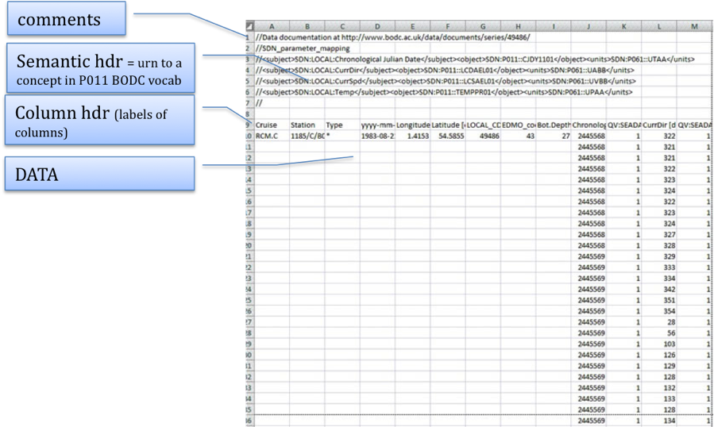

NetCDF
NetCDF is a set of data formats, programming interfaces, and software libraries that help read and write scientific data files. NetCDF was developed and is maintained at Unidata, that is part of the University Corporation for Atmospheric Research (UCAR) Office of Programs (UOP). Unidata is funded primarily by the US National Science Foundation. Unidata provides data and software tools for use in geoscience education and research.
NetCDF files are self documenting. That is, they include the units of each variable and notes about what it means and how it was collected
Like most binary formats, the structure of a netCDF file consists of header information, followed by the raw data itself. The header information includes information about how many data values have been stored, what sorts of values they are, and where within the file the header ends. NetCDF fits specifically to store multidimensional data arrays.

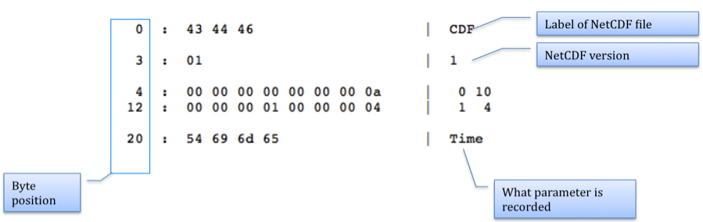

Data transport for Geophysical data

Introduction
As from the Utrecht and Bruxelles meeting it was decided to handle the following set of geophysical data:
- Gravimetry (tracking)
- Gravimetry (gridded)
- Magnetic (tracking)
- Magnetic (gridded)
- Bathymetry (tracking)
- Bathymetry (gridded+swath)
- Heat flow
- Seismics (scanned images)
- Seismics (digital data)
- Seismics (navigation)
- Side scan sonar
With the addition of two data types that do not strictly pertain to Geophysics only
- Images
- Maps (considered data product)
In the view of easing data access by the end users, Geoseas adopt as a fundamental criterion that of minimizing as much as possible the number of standards to be use within the project.
Soon it was clear (see minute of the Utrecht meeting) that most of the data types mentioned and the relative practices implied could be quite easily handled using the methods and technologies developed within SeaDatanet. This is due to a similar sampling strategy as that of most of the oceanography data.
Therefore partners converged on the criteria that:
- Tracking data (data that are sampled along a trackline) will be handled through the ODV format
- Gridded data (data shared referring to a grid, as for example a DTM) will be handled through the netCDF format
Most of marine geophysical data can therefore be share in both ways, in fact recordings are generally made along tracks, but after some processing, maps are produced that correspond to gridded data. Partners are free to decide which of these possibilities fits better their case.
Therefore, for example in the case of Gravimetric or magnetic data, when considering raw data, these can be stored within ODV files, or in the case of processed grids can be stored within netCDF files.
The Seismic and Side scan sonar data types are peculiar compared to that. This is up mainly to the sampling strategy adopted in this field and the kinds of products available, which are different form the others, therefore It was decided to introduce for these data types specific data formats as SEG-Y, P1/90 and XTF.

4.2 Transport format specifications for Seismic data
In Seismics, traces are acquired that correspond to arrivals at one (single fold) or multiple (multi-channel) receivers of an acoustic wave originated in a source positioned at a variable distance to the receivers.
Seismic data products are profiles in two way time (that can be converted to depths using acoustic waves velocities) along a track. This sampling strategy was always handled separating the track/navigation and the actual data in two files with different formats, the most common of which are SEG-Y and P1/90

4.2.1 The SEG-Y format
The SEGY format was introduced by the Society for Exploration Geophysics in 1975 and acquired a widespread usage.
Considering the situation in 1975 Seismics evolved quite considerably, so that new needs appeared for which the original specifications were not elastic enough.
New practices required interpretations of the original format design to accommodate the new needs, resulting in a speciation of SEG-Y in several dialects. This tendency was happily supported by software houses that added a marketing perspective to dialects, This tended to isolate users within brand-oriented habits. In 2001 SEG published a revision of the SEG-Y format to consolidate and secure the SEG-Y format from this tendency. GeoSeas will refer to this revision.
With the aim to ease the work of Data Managers, GeoSeas will require a minimum set of mandatory parameters that are considered essential for Seismic data usage, leaving to the partners the option to fill other fields they might find useful to report, following SEG-Y revision1 prescriptions. The specifications of SEG-Y can be found in the appendix
The SEG-Y file may be written to any medium that is resolvable to a stream of variable length record. Traditionally SEG-Y files were written to tapes. To write them into media as hard disk, CD-ROM, DVD or similar the convention is to use “big-endian” byte encoding, the same as if the file was written to a tape. For those who might not be familiar with the concept of little or big endianness it is suggested to read the article at this web address:
http://betterexplained.com/articles/understanding-big-and-little-endian-byte-order/
The structure of a SEG-Y file can be seen in Figure 1. It shows that a SEG-Y File is divided in two sections:
- Reel header: a section that records parameters common to all the seismic line and relative data.
Within the Reel Headers, other subsections can be identified (red stands for mandatory, green for optional):
  - Optional SEG-Y tape label (not required by GeoSeas and very seldom used anyway)
  - 3200 bytes Textual File Header
  - 400 Bytes Binary File Header
  - Optional Extended Textual File Header. This can be repeated several time (not required by GeoSeas, left optional)
- Traces: a section that gather seismic traces. Each trace data is preceded by a trace header recording its parameters and that separates it from the previous trace.
  - 240 bytes Textual File Header
  - Actual trace data values

Please note that:
- All values recorded into the Binary File Header and any Trace Header are two’s complement integers, either 2 or 4 byte long. No floating point is admitted.
- Trace Data sample values are either two’s complement integers or floating point. SEG-Y revision 1 added to the original format the possibility to use sample formats of 8-bit integer and 32-bit IEE floating point. Both IBM floating-point and IEEE floating point values are written in big endian order

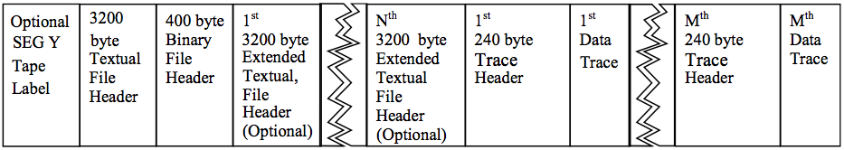
Figure 1 Structure of a SEG-Y file

4.2.1.1 Textual file header
The first 3200-bytes, textual file header record contains 40 lines of 80 columns textual information. These provide a human readable description of the seismic data in the file. This information is in free form although SEG provide a suggested layout for the first 20 lines (Appendix, figure 3)
In the perspective to ease the work of data managers, recalling that within GeoSeas most of the information pertinent to this section should already be present in the CDI or its O&M extension document, it is to remark that for GeoSeas this section is not that important as in its normal usage.
In fact GeoSeas requires to report here in a free text format only the following information

- the owner or provider of the data
- the CDI_LOCAL_ID of the dataset (same as in CDI)
- the agreement or licence on the use of the data (same as in CDI)
- (if applies) the notification of digitization from a paper section

It is to be highlighted that using SEG-Y no validation facility can be set up as in the case of XML, then errors in compilation of this section are possible and should be under the responsibility of the single data manager. At the same time, considering that this information will be present also in the CDI+O&M part, the whole process of data handling should not suffer too much form the possible presence of errors in the SEG-Y file, that will remain confined and will not spread through all the process of data discovery, access and usage.
GeoSeas, while supporting it, leaves to the initiative of the partners the possibility to follow the schema of figure 2
Since the textual header is not considered very important, then the possibility to use the extended textual file header is not required either. Therefore the Binary File Header location 3505-3506 will be set to zero by default. In case partners wish to include such an extension (for example if the information they wish to place in the SEG-Y is longer that 3200 byte block), it is important that they set at that location the number of Extended blocks they wish to use.

4.2.1.2 Binary reel header
The Binary File Header contains binary values that affect all the seismic line.
Also here, to ease the work of data managers, we list the mandatory fields, while leave to the partner the possibility to fill the other fields.

Bytes loc. | description | mandatory
3217-3218 | Sample interval (microseconds) | yes
3221-3222 | n samples per data trace | yes
3225-3226 | Data sample format code  1= 4-byte IBM floating point (recommended) (*)  2= 4-byte, two’s complement integer  3= 2-byte two’s complement integer  4= 4-byte fixed point with gain (obsolete)  5= 4-byte IEEE floating point  6= not used  7= not used  8= 1-byte, two’s complement integer | yes
3227-3228 | CDP fold | if available
3229-3230 | trace sorting  -1=Other (should be explained in text header)  0=Unknown  1= as recorded (no sorting)  2= CDP ensemble  3= single fold comtinuous profile  4= Horizontally stacked  5= common source  6= common receiver  7= common offset  8= common mid-point  9= common conversion point | yes
3251-3252 | Gain recovery  1= yes  2= no | If Vintage data
3253-3254 | Gain recovery method  1= none  2= spherical divergence  3=AGC  4=Other | If Vintage data

(*) Recommended IBM floating point data sample format code.
We would like to remember that the original SEG-Y data format (tape based) appeared in 1975, when technology was highly conditioned by the IBM standards, so that the original format was IBM floating point.
Later, technology drove floating point to IEEE, so that at the moment all computers interpret floating point as the latter, then it is quite easy to fall in the error of reading IBM f.p. with IEEE f.p. technology. This coupled with the fact that not all processing or interpretation software are updated with SEG-Y revision1 prescriptions can create serious problems as those that can be seen in the simplified example of Figure 2 (Meisinger, 2004) where a simple sinusoid signal is erroneously represented. When the actual seismic signal is recorded, complex phases appear so that it could be difficult even to realize if the problem exist.
The GeoSeas project request to adhere as strictly as possible to the original format, then using the IBM floating Point representation, but in case partners would like to use IEEE f.p. representation they must set byte 3225-3226 of the Reel header to code 5.

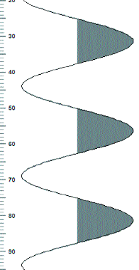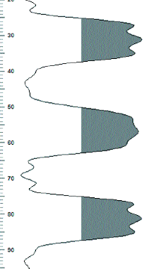

Figure 2 A simplified sinusoid plotted using its correct floating point representation (left) and using the wrong one (right) (Meisinger, 2004)
The trace header contains trace attributes. Which are defined as two-byte or four byte, two’s complement integers. The values in byte 1-180 were defined in the 1975 standard and these entries remain unchanged in the revision 1. Bytes 181-240 were for optional information originally and this has been the main area where dialects were developed.
There has always been ambiguities regarding where to put the shot-point number (*). Byte 9-12 is reserver for original filed record number. Byte 17-20 can be used when more that one record occurs at the same effective surface locations, then SEG-Y revision1 recommends to move the Shot point number field to byte 197-202, but at the same time SEG acknowledge that this works only in the case of 2D post-stack data. Many interpretive and processing software do not seek automatically shot point values at byte 197-202, rather at byte 17-20 or even 9-12. then we suggest to copy the shot point value in all three locations.
GeoSeas will use for positioning the Ukooa P1/90 format then entering positioning in the SEG-Y file will be at the discretion of the partner.
In the case of standard seismics, receiver or source depth is not an issue

bytes | description | mandatory
1-4 | Trace sequence number within line – numbers continue to increase if the same line continues acreoss multiple SEG-Y files | yes
9-12 | original FFID (*) | yes
13-16 | Trace number within the original field record | If pre-stack
17-20 | Energy Source point (*) | yes
21-24 | CDP (assumes geometry is installed) | if available
25-28 | trace within CDP (assumes geometry is installed) | if available
29-30 | Trace iD should be 1 (possibly dead/dummy). | yes
37-40 | offset ( assumes geometry was already installed + pre-stack) | If available
41-44 | Receiver elevation (see 45-48)
45-48 | to be discussed: delays should be applied or only reported see also byte 109 If used, bytes 69-70, scaler be applied to all elevations and depths specified in bytes 41-68
69-70 | Scalar for elevations
109-110 | Delay recording time See 45-48
115-116 | n samples | yes
117-118 | sample interval in microsec | Yes
197-202 | Shot-point number (*) | 2D post-stack
(*) the same value is stored at byte 9-14,17-20,197-202

4.3 Transport format specification for Seismic Data positioning
Following the Utrecht, Lisbon and Brussels meetings, it was decided to follow the common practice used in Seismics that keep positioning and the actual seismic data separated.
In fact, albeit the chosen format for seismic data transport (SEG-Y) allows for storing positioning information, the community uses for positioning the UKOOA formats.
The United Kingdom Offshore Operators Association (UKOOA) in the nineties released several standards for data positioning exchange. The OGP Surveying and Positioning Committee was formed in 2005 by the absorption into OGP of the now-defunct European Petroleum Survey Group (EPSG) which itself had been formed in 1986. The activities of these associations, led to the formalization of several revised positioning formats among which GeoSeas will adopts for data transport the:
P1/90 Data Exchange Format - Post Plot
This format is widely accepted by most of interpretive and processing software and commonly shared in the designated community.
Although its formalization is quite strict is can be used following several interpretations, that mainly depends on the available data considered.
In this, GeoSeas will adopt a pragmatic approach with the aim of easing as much as possible the work of data managers, keeping mandatory information at minimum.
Please note that it is assumed that navigation reported in these files is not raw but an already processed/post-plot version.
The complete description of the position of every entity related to acquisition is achieved applying what is generally referred to in Seismics as “geometries”. This task requires the use of specific software that some partners might not own.
It was decided then to consider mandatory the position of the shot point only. This applies both in the case of pre-stack or post-stack data.
Each seismic line should have its own navigation file. Possible segments of the same seismic line (as in the case of vintage data) could point to several files via the O&M extension to the CDI, but there should be just one navigation file per seismic line.
Information regarding the configuration of acquisition system will be reported in the O&M extension to the CDI, where it will be validated automatically.
In the case of Post-stack data the need for a full description of acquisition configuration is not very important, while in the case of pre-stack data, geometry information is fundamental otherwise it is impossible to define the correct geometries to apply to data.
4.3.1 P1/90 description
P1/90 is an ASCII file made of two sections:
- Header record
Each file should start with a number of header records, which contain information about, and parameters controlling, all of the data record section
- Data record
This section contains the actual positioning of data.
Header record
The general format for header record is

 | Columns | Format
a) Record Identifier “H” | 1 | A1
b) Header Record Type | 2 – 3 | I2
c) Header Record Type Modifier | 4 – 5 | I2
d) Parameter Description | 6 – 32 | A27
e) Parameter Data | 33 – 80 | See example and specifications below

Text fields should be left justified, and numeric fields right justified unless otherwise stated.
The full list of available Header record fields of the UKOOA P1/90 Format can be found in Appendix 1
In the view of easing the work of Data managers, and recalling the fact that within GeoSeas and SeaDataNet positioning is intended based on the World Geodetic System 1984 (WGS 84) datum CRS, most of the header fields, which actually report projection parameters are not relevant. This allows, within GeoSeas to share positioning files based on a strongly simplified, although compliant, version of the P1/90 format. This comprises mandatory (red in the following example) and recommended (green) Headers. Data managers are free to add to this other P1/90 headers as long as they follow the rules and specifications of the format, as in the appendix to this document.
4.3.1.2 Mandatory headers:
  - H0800: considering that only shotpoint position will be required (the term ‘shotpoint’ refers to the ‘centre of source’) H0800 will need to be filled with the text “Centre of Source”
  - H8000, H8001: for improved machine readability and/or to enable integrity checking of coordinate systems definitions in UKOOA, provision is made to describe co-ordinate system by reference to the European Petroleum Survey Group (EPSG) database of geodetic parameters. This allows an industry-standard name to be quoted where the geodetic co-ordinate system used is a common system. Defining parameters and units are then as given by EPSG and are not strictly required to be explicitly given in the P-formats records.
In this perspective the P1/90 format must report the following headers:
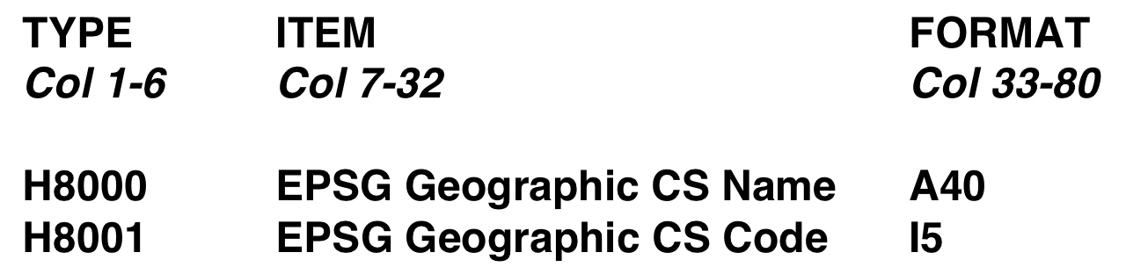
4.3.1.3 Recommended headers:
Please note that all the following fields accept free text. No automatic validation based on a vocabulary is possible, so that it is quite easy to introduce errors. This information will be present also in the O&M extension to the CDI where instead validation will be performed. Once the end user receives the data, this can be analyzed separately form the CDI and its O&M extension, then it could be of some help to find immediately some critical information. We suggest to include in the P1/90 file the following basic information:
  - H0100: Area of the survey
  - H0102: Vessel detail. In case this header is used, after the name of the vessel (at columns 60) an id code should be entered for the latter. We suggest of course to use the integer “1”. the P1/90 format prescribes that the following data record describing shots should report this identification code in column 17
  - H0103: Source detail. In this header it is possible to place the type of source used. In case this header is used after the type of the source (at columns 60) an id code should be entered for the latter. We suggest of course to use the integer “1”. the P1/90 format prescribes that the following data record describing shots should report this identification code in column 18
  - H0200: Survey date.

Example 1: GeoSeas P1/90 Header record as require by GeoSeas
(red: mandatory, green: recommended, black: column postion)

0000000001111111111222222222233333333334444444444555555555566666666667777777777
1234567890123456789012345678901234567890123456789012345678901234567890123456789
H0100 SURVEY AREA Adriatic Sea
H0102 VESSEL DETAILS OGS EXPLORA 1
H0103 SOURCE DETAILS AIRGUN 1
H0200 SURVEY DATE March 2010 to April 2010
H0800 Co-ordinate location Centre of Source
H8000 EPSG Geographic CS NameWGS84 Geographic 2D
H8001 EPSG Geographic CS Code 4326

4.3.1.4 Data Record
The P1/90 data set consists of one file per seismic line with header records followed by a series of “Data Records” containing one shotpoint position each. GeoSeas considers this the minimum requirement, while leave to the partners the possibility to extend the data record to report CDP or binning as long as they follow the prescriptions of P1/90 format. To report Shot point position, the header record H0800 should be present and refer to Center of Source.Please note that For line name only 11 char are allowed. The data record should follow this format :

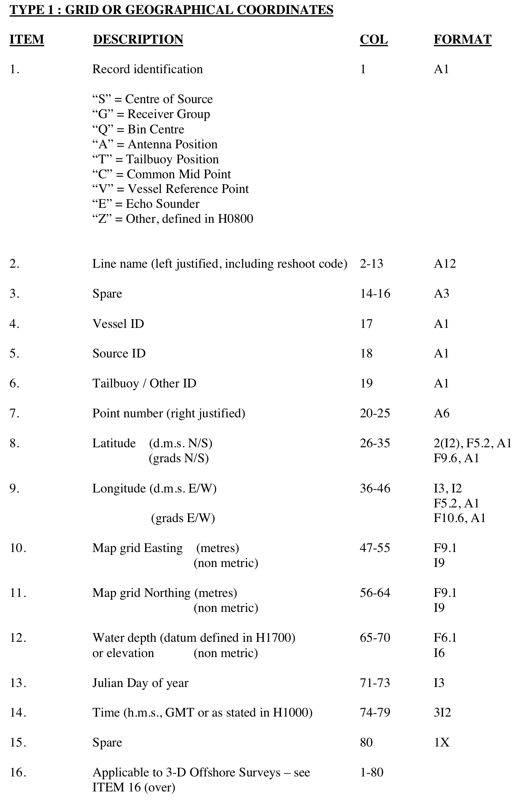
Example 2: GeoSeas P1/90 Data record as require by GeoSeas
(red: mandatory, green: recommended, black: column postion)

><-------------><-><-----><---------><-------->
0000000001111111111222222222233333333334444444444555555555566666666667777777777
1234567890123456789012345678901234567890123456789012345678901234567890123456789
S89-100 11 101214333.48N114 552.59E
S89-100 11 102214333.61N114 553.50E
S89-100 11 103214333.59N114 554.33E
S89-100 11 104214333.55N114 555.20E
S89-100 11 105214333.50N114 556.12E
4.3.1.5 3D case.
As in the case of pre-stack data also in the 3D case GeoSeas considers mandatory only the Shot position. Geometry application can follow the O&M acquisition system configuration and is an end user responsibility.
Please note that commonly in this case positioning is not geodetic rather projected. This does not comply with the philosophy of GeoSeas-SeaDataNet, then we discourage such application. For the sake of completeness we report here the prescription in the 3D case and an example

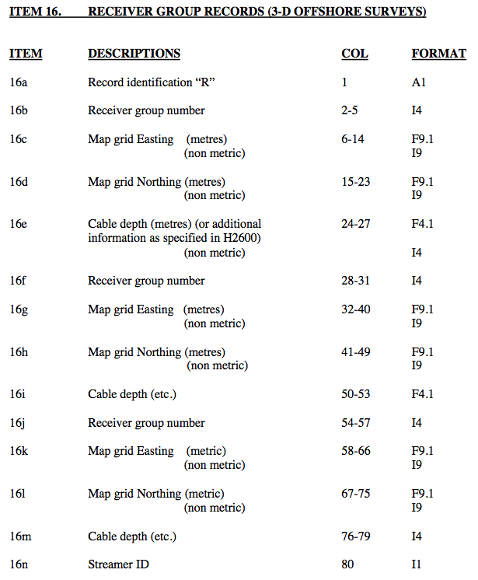

Example 3: P1/90 Data record in the 3D case
(not required by GeoSeas)

0000000001111111111222222222233333333334444444444555555555566666666667777777777
1234567890123456789012345678901234567890123456789012345678901234567890123456789

S52 111 339 247.5 504.2 0266161322

R 1 254.7 491.0 0.0 2 254.9 489.0 0.0 3 255.1 487.0 0.01

R 4 255.3 485.1 0.0 5 255.5 483.1 0.0 6 255.7 481.1 0.01

R 7 250.7 491.4 0.0 8 250.9 489.4 0.0 9 251.1 487.4 0.02

R 10 251.3 485.5 0.0 11 251.5 483.5 0.0 12 251.7 481.5 0.02

R 13 246.8 491.8 0.0 14 247.0 489.8 0.0 15 247.2 487.8 0.03

R 16 247.4 485.9 0.0 17 247.6 483.9 0.0 18 247.8 481.9 0.03

R 19 242.8 492.2 0.0 20 243.0 490.2 0.0 21 243.2 488.2 0.04

R 22 243.4 486.3 0.0 23 243.6 484.3 0.0 24 243.8 482.3 0.04

S52 111 340 247.6 505.3 0266161322

R 1 254.8 492.2 0.0 2 255.0 490.2 0.0 3 255.2 488.2 0.01

R 4 255.4 486.2 0.0 5 255.6 484.2 0.0 6 255.7 482.2 0.01

R 7 250.8 492.6 0.0 8 251.0 490.6 0.0 9 251.2 488.6 0.02

R 10 251.4 486.6 0.0 11 251.6 484.6 0.0 12 251.8 482.6 0.02

R 13 246.8 493.0 0.0 14 247.0 491.0 0.0 15 247.2 489.0 0.03

R 16 247.4 487.0 0.0 17 247.6 485.0 0.0 18 247.8 483.0 0.03

R 19 242.8 493.4 0.0 20 243.0 491.4 0.0 21 243.2 489.4 0.04

R 22 243.4 487.4 0.0 23 243.6 485.4 0.0 24 243.8 483.4 0.04

S52 111 341 247.6 506.5 0266161322

R 1 254.8 493.4 0.0 2 255.0 491.4 0.0 3 255.2 489.4 0.01

R 4 255.4 487.4 0.0 5 255.6 485.4 0.0 6 255.8 483.4 0.01

R 7 250.8 493.8 0.0 8 251.0 491.8 0.0 9 251.2 489.8 0.02

R 10 251.4 487.8 0.0 11 251.6 485.8 0.0 12 251.8 483.8 0.02

R 13 246.8 494.2 0.0 14 247.0 492.2 0.0 15 247.2 490.2 0.03

R 16 247.4 488.2 0.0 17 247.6 486.2 0.0 18 247.8 484.2 0.03

R 19 242.9 494.6 0.0 20 243.1 492.6 0.0 21 243.3 490.6 0.04

R 22 243.5 488.6 0.0 23 243.7 486.6 0.0 24 243.8 484.6 0.04

4.4 Transport format specifications for side-scan sonar
Side-scan sonar is another data type, as seismics, where the specific sampling strategy and the traditions of the communities that use it advise for the introduction of a specific format, different from ODV or NetCDF. The most commonly used format in this field is XTF (eXtended Triton Format) which being a commercial standard developed by Triton inc. does not have the problems of dialect speciation mentioned before in the case of SEG-Y. Data are already available in a standardized way therefore no hassle should be imposed to the end user. For specific format specification please refer to the following address:
http:///www.tritonimaginginc.com/site/content/public/downloads/FileFormatInfo/Xtf%20File%20Format_X26.pdf
The XTF format is tailored for real-time data collection of several data types at the same time. Data may be prepared and added to the file at any time without the need to synchronize data, in fact packets bathymetry data may be logged five times per second while sonar data can be logged 10 times per second. No storage space is wasted and no "holes" are created in the saved data stream.
While processing an XTF file, the processing software can easily ignore data packets it doesn't recognize or isn't needed. This will allow to use the same structure for possible future datatypes not developed yet.
XTF files has a file header record named the XTFFILEHEADE, which has structure of a minimum of 1024 bytes in length. If can be larger than 1024 bytes when the total number of channels to be stored in the file is greater than six (the number of CHANINFO structures contained in the XTFFILEHEADER structure causes the XTFFILEHEADER structure to grow larger than 1024 bytes).
After the header, data packets may follow in any order. Each packet must contain a packet header, which identifies the type of packet and the number of bytes in the packet. If the software does not recognize the packet type, it can skip forward the given number of bytes to the next packet. Thus, the packets can be thought of as a linked list of data elements which vary in size. To make file search easier, all data packets must be an even multiple of 64 bytes in length.
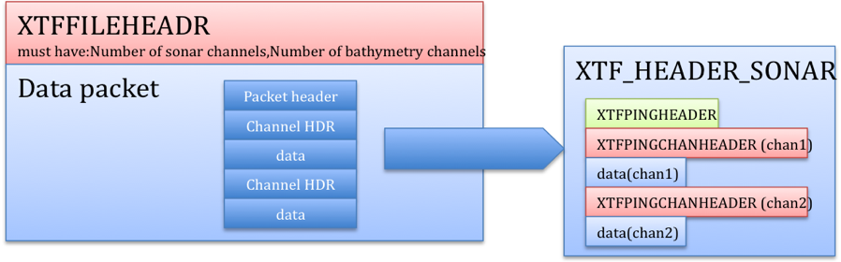
Figure 3 Schema of the XTF format for sidfe-scan sonar data

References:
- Meisinger, D. 2004, “SEGY Floating Point Confusion”, CSEG recorder, 2004, pag 36-39.
- (original standard) Barry, K. M., Cavers, D. A. and Kneale, C. W., 1975, Report on recommended standards for digital tape formats: Geophysics, 40, no. 02, 344-352.
http://www.seg.org/SEGportalWEBproject/prod/SEG-Publications/Pub-Technical-Standards/Documents/seg_y_rev0.pdf

- (SEG Y revision 1) addresses these changes and updates the format for modern usage.
http://www.seg.org/SEGportalWEBproject/prod/SEG-Publications/Pub-Technical-Standards/Documents/seg_y_rev1.pdf

- OGP P1/90 full specifications at this site:
http://www.epsg.org/Exchange/P1.pdf

- XTF fiel format:
http:///www.tritonimaginginc.com/site/content/public/downloads/FileFormatInfo/Xtf%20File%20Format_X26.pdf

Appendix 1 Full technical specification for SEG-Y format

Text Reel header

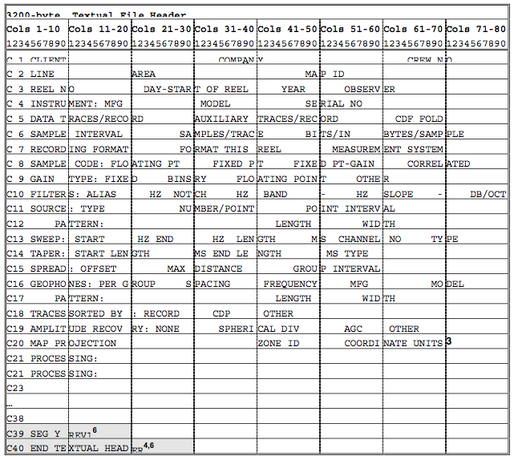
Figure 4 Textual Reel Header as suggested by SEG

Binary Reel header

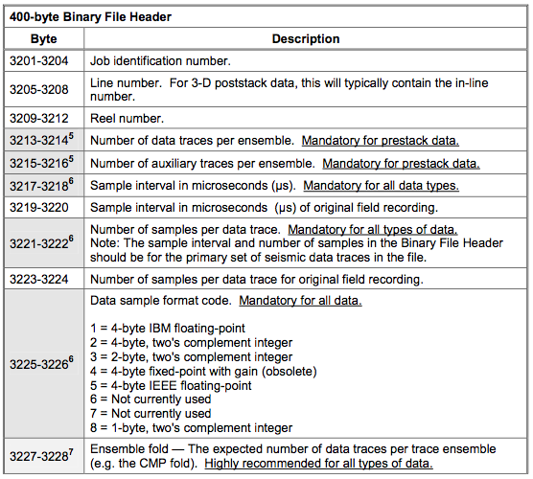
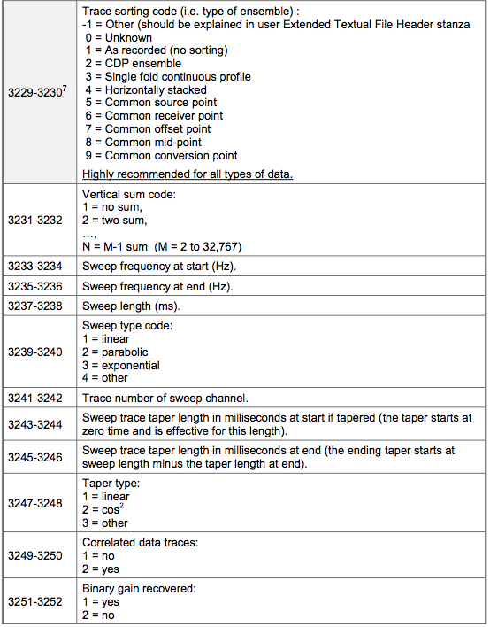
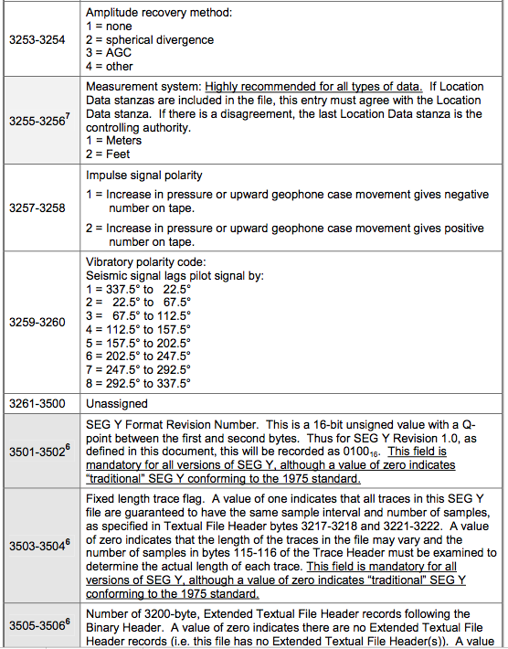
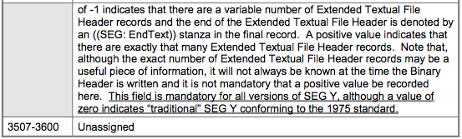

Trace Header
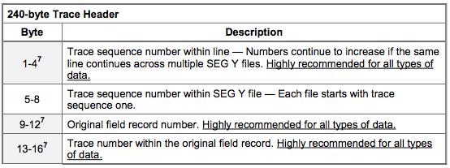
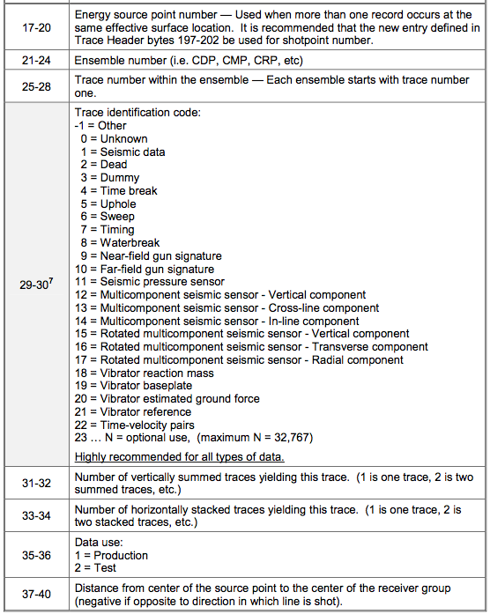
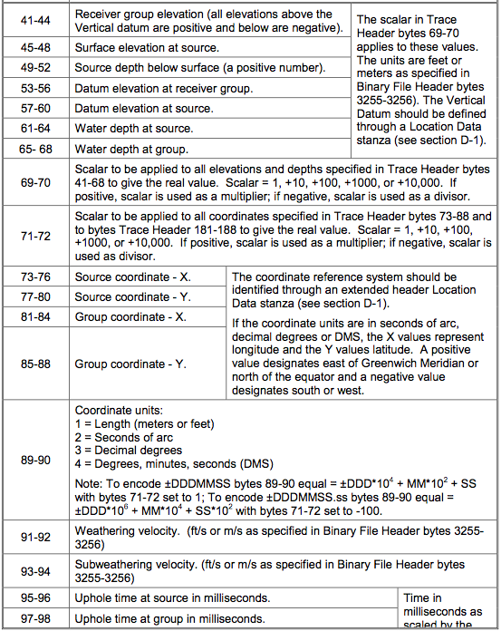
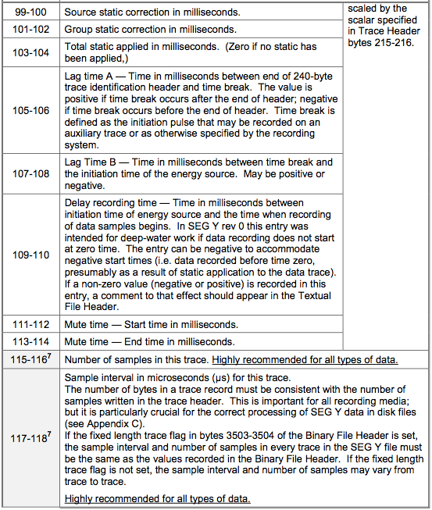
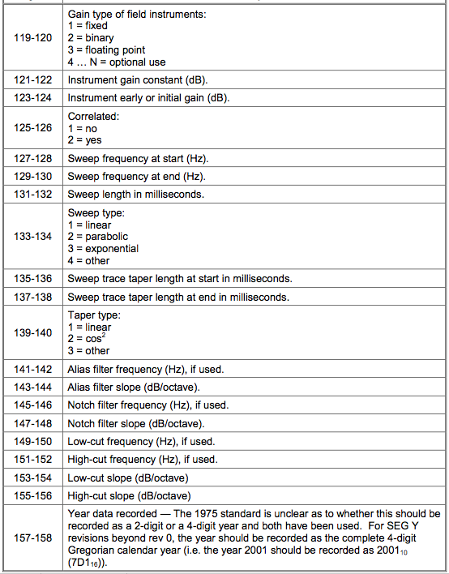
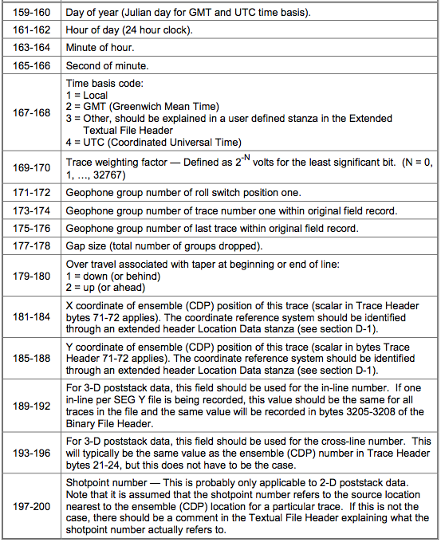
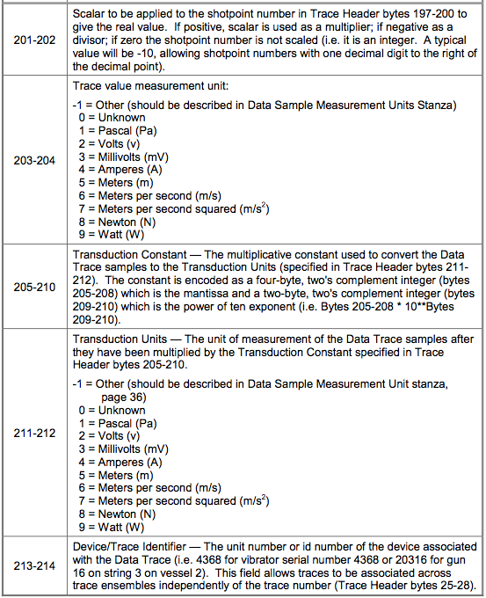
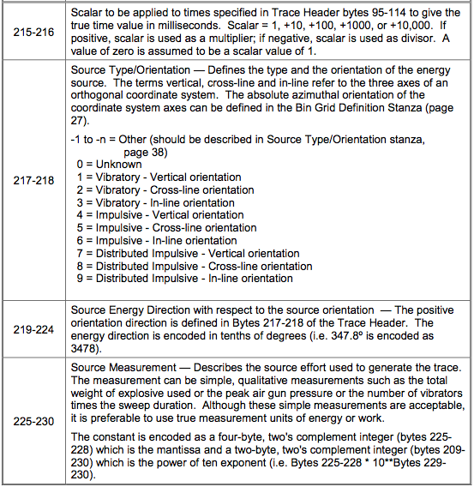
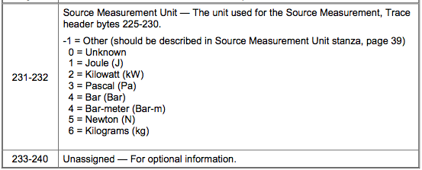

Appendix 2 Format Specification for P1/90 file format
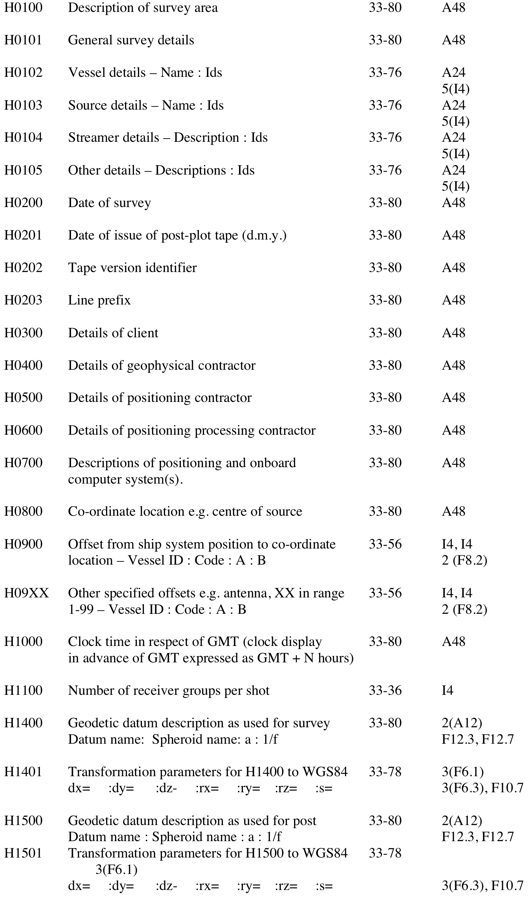
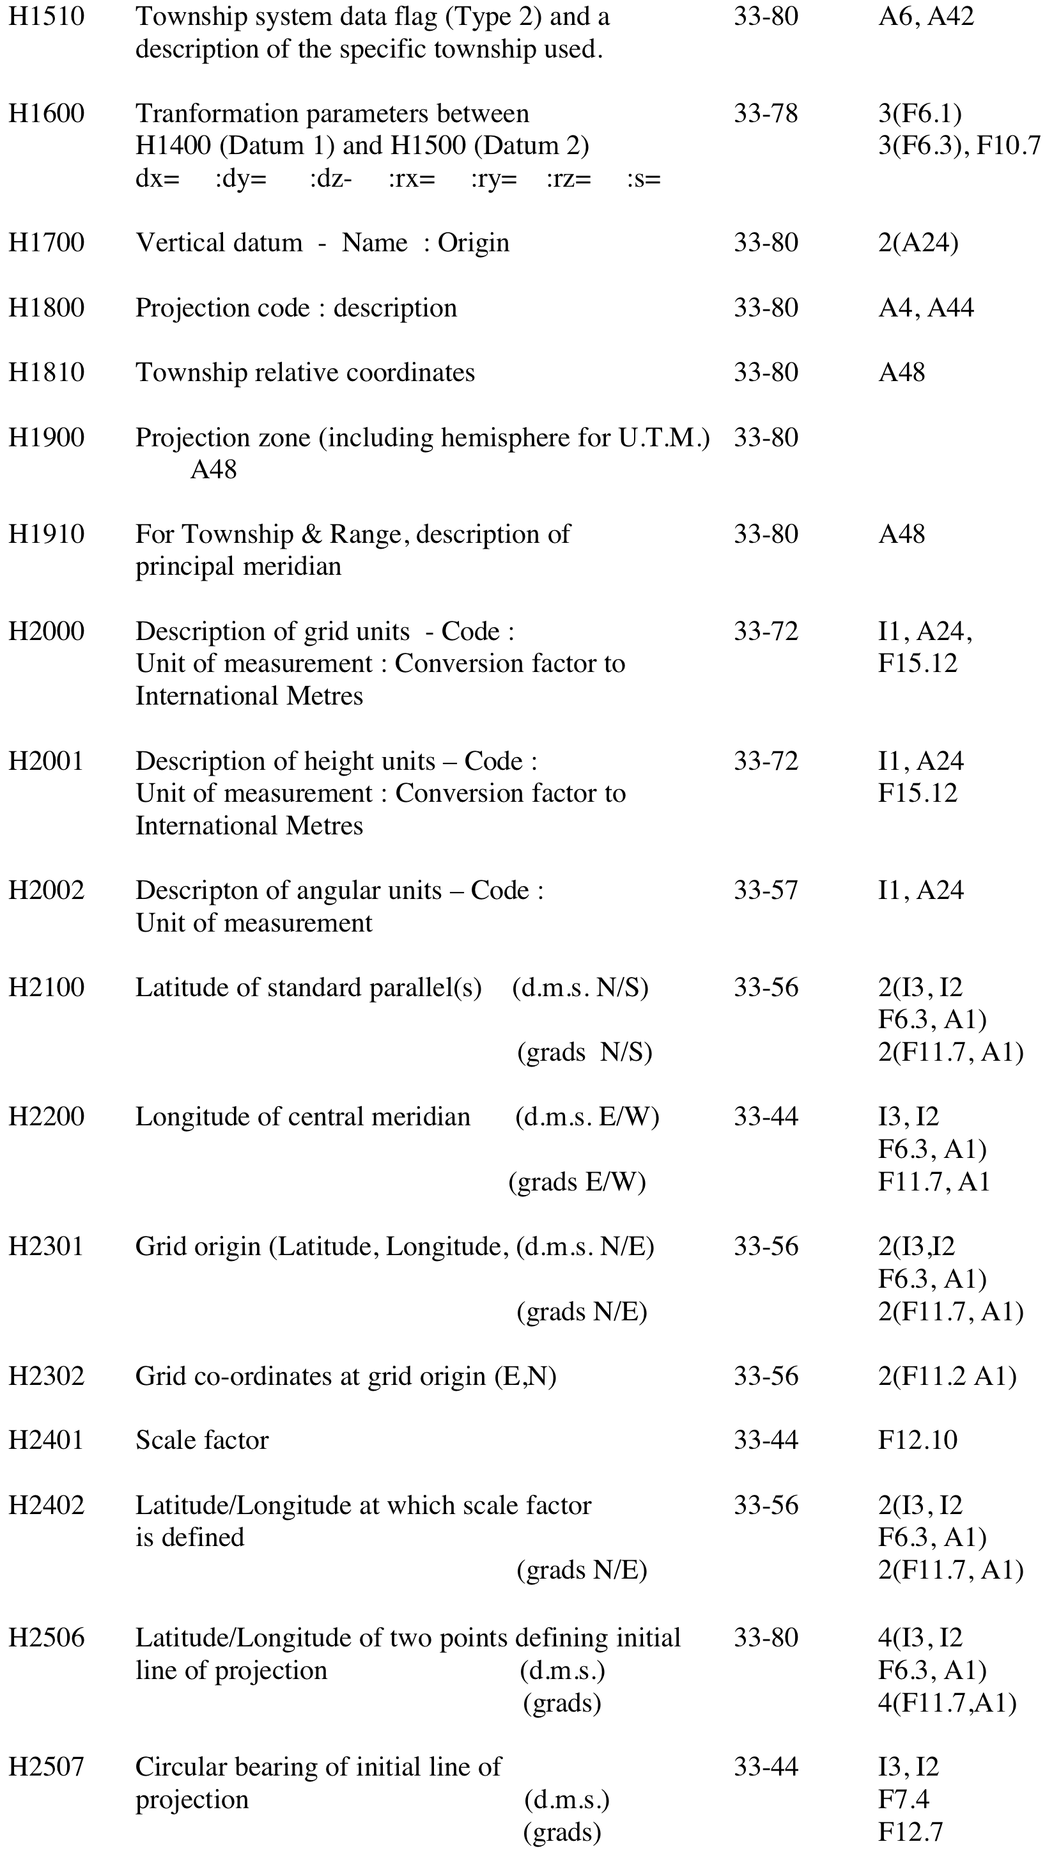
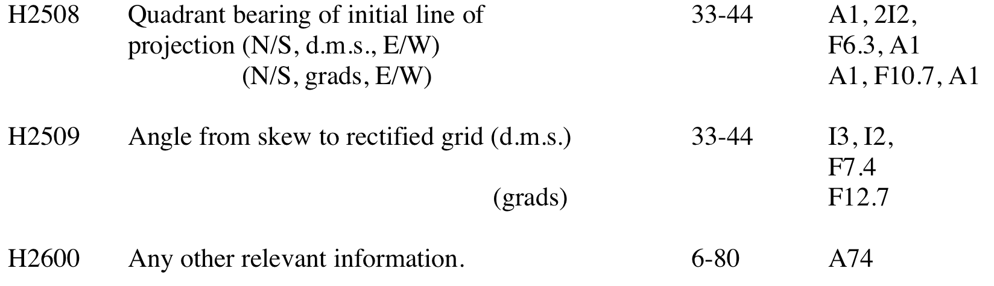

Appendix 3 Example of Header record (as from UKOOA documentation)

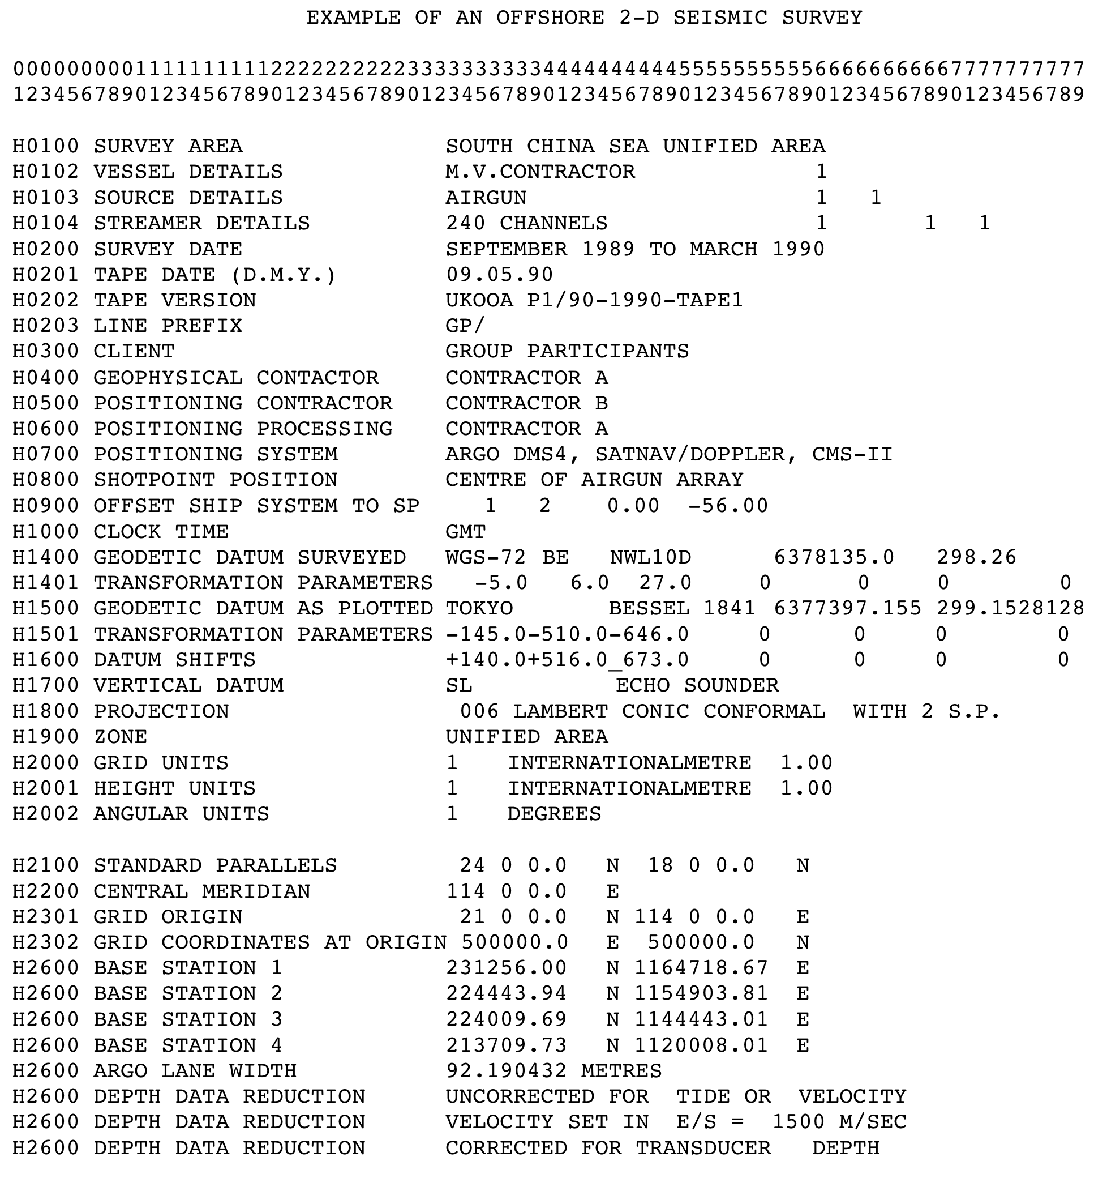

Appendix 4 Example of Data record (as from UKOOA documentation)



